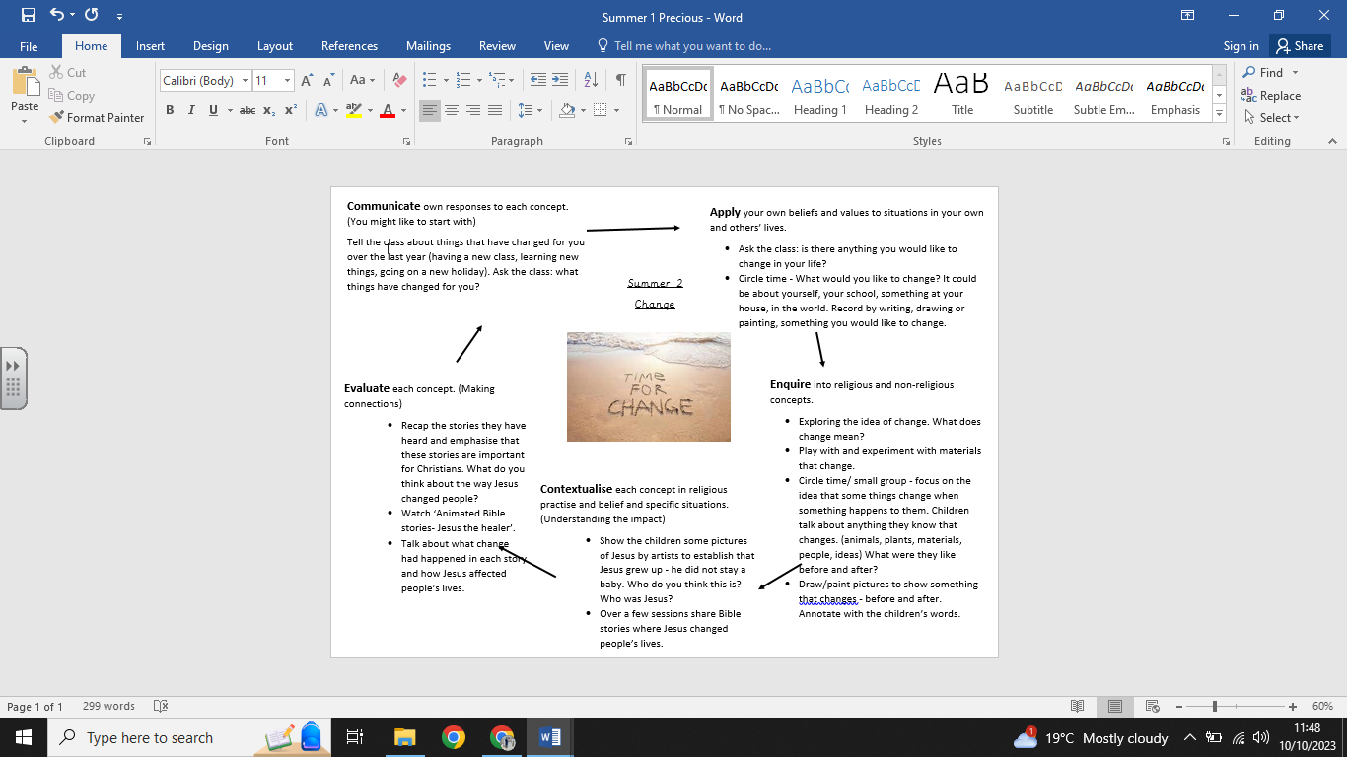

**What we are going to learn next time:**

-Forgiveness means to let go of negative feelings about something.

-A parable is a story in the Bible.

-That Jesus gives instructions about how to behave through parables.

-How Christians show love through forgiving others.

**What we already know:**

No prior knowledge presumed.

**What we are going to learn:**

* Jesus is a special person for Christians.
* Jesus was a teacher and healer and he had many followers.
* There are many stories about Jesus in the Bible, which show how people changed when they met Jesus.
* What change can mean for us.

**Key Vocabulary:**

* Change
* Zacchaeus
* New Testament
* Jairus’ daughter
* Jesus

**Religious Education Knowledge Organiser: Year R**

**Summer 2: Change**