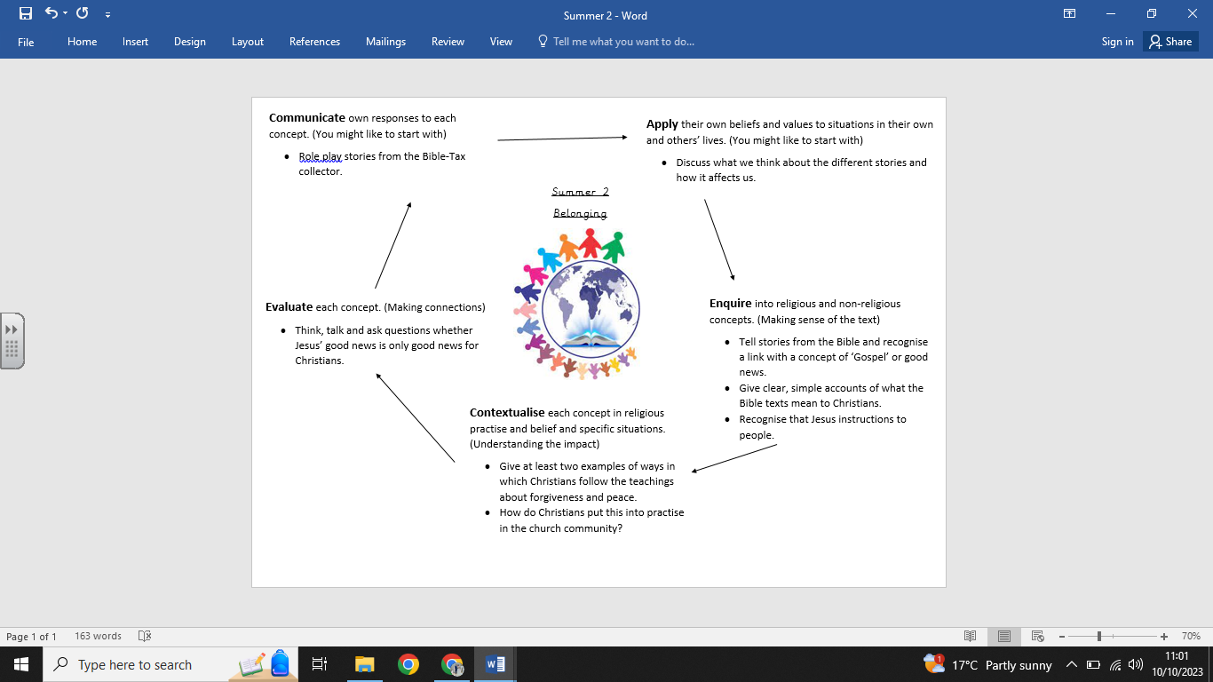

**What we already know:**

* Forgiveness means to let go of negative feelings about something.
* A parable is a story in the Bible.
* That Jesus gives instructions about how to behave through parables.
* How Christians show love through forgiving others.

**What we are going to learn:**

* Stories from the Bible and recognise a link with a concept of ‘Gospel’ or good news.
* What Bible texts (such as the story of Jonah) mean to Christians.
* That Jesus gives instructions to people about how to behave.
* Examples of ways in which Christians follow the Jesus’s teachings about forgiveness and peace and friendliness.
* Examples of how Christians put these beliefs into practice in the Church community and their own lives.
* About whether Jesus’ ‘good news’ is only good news for Christians, or if there are things for anyone to learn, exploring different ideas.

**What we are going to learn next time:**

Incarnation and the trinity

(Year 3: Horndean Church of England junior school)

**Key Vocabulary:**

* Gospel
* Belonging
* Jonah
* Christians
* Jesus
* Good news

**Religious Education Knowledge Organiser: Year 2**

**Summer 2: Belonging**