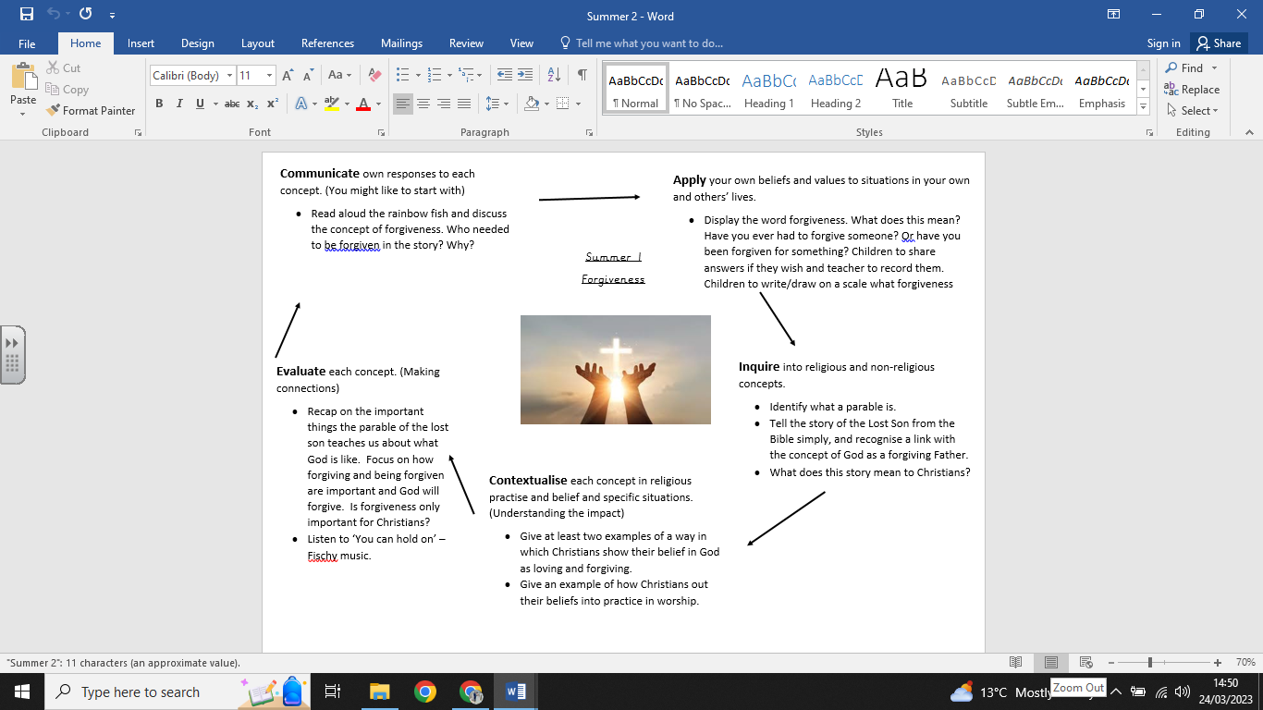

**What we are going to learn:**

* Forgiveness means to let go of negative feelings about something.
* A parable is a story in the Bible.
* That Jesus gives instructions about how to behave through parables.
* How Christians show love through forgiving others.

**What we are going to learn next time:**

**Key Vocabulary:**

* God
* Jesus
* Forgiveness
* Parable
* Love
* Bible
* Church

**What we already know:**

**Religious Education Knowledge Organiser: Year 1**

**Summer 2: Forgiveness**