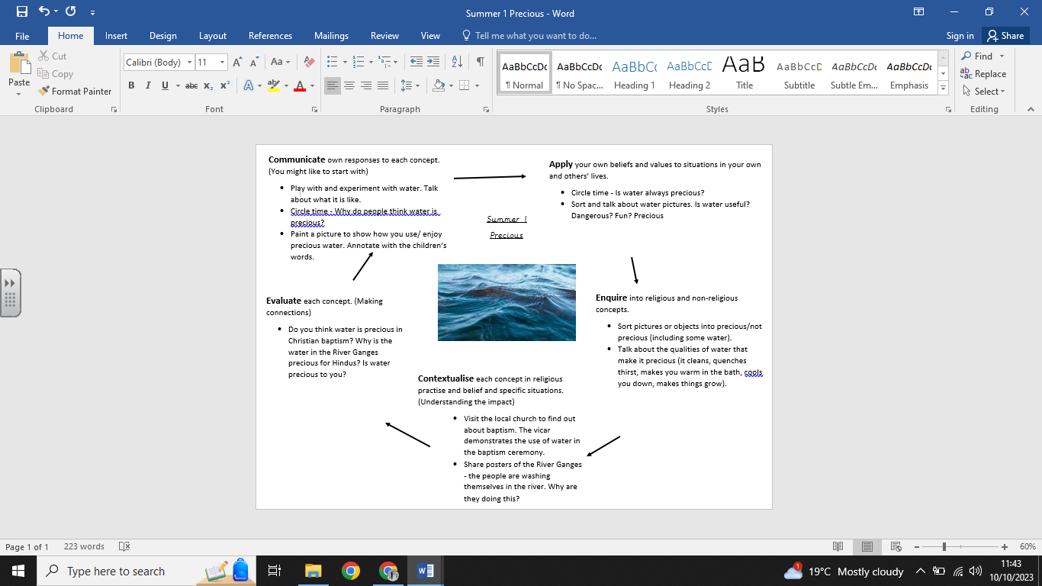

**What we are going to learn:**

* Christians use water in a special ceremony called baptism, which welcomes people into the church.
* Babies or adults can be baptised.
* Babies and adults often wear special clothing.
* Christians tell the story of John of Baptist who baptised Jesus in the river Jordan.
* Hindu people see the River Ganges as precious.
* About the story of Shiva.

**What we are going to learn next time:**

- The concept of creation.

- Describe Christian and Hindu creation stories.

-Describe Hindus value these stories

-Give examples of how their responses to creation relates to their own and others’ lives

**Key Vocabulary:**

* Water -John the Baptist
* Precious -River Jordan
* Church
* Baptism
* Hindu faith
* River Ganges
* Shiva

**What we already know:**

No prior knowledge can be presumed.

**Religious Education Knowledge Organiser: Year R**

**Summer 1: Precious**