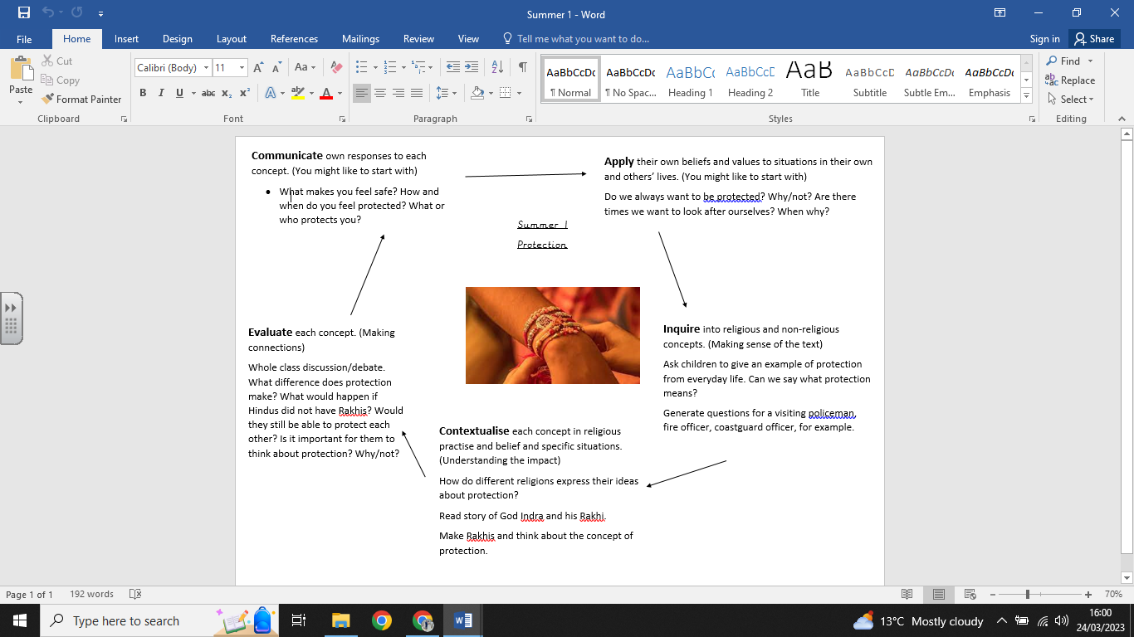

**What we are going to learn:**

* The concept of protection.
* To describe how Hindus express protection in the festival of Raksha Bandhan.

**What we already know:**

* The concept of creation.
* Describe Christian and Hindu creation stories.
* Describe Hindus value these stories
* Give examples of how their responses to creation relates to their own and others’ lives.

**What we are going to learn next time:**

Sacred – The Gurdwara

Year 3 (Horndean Church of England Junior School)

**Key Vocabulary:**

* Raksha Bandan
* Protection
* Rakhis
* Lord Vishnu
* Indra

**Religious Education Knowledge Organiser: Year 2**

**Summer 1: Protection**