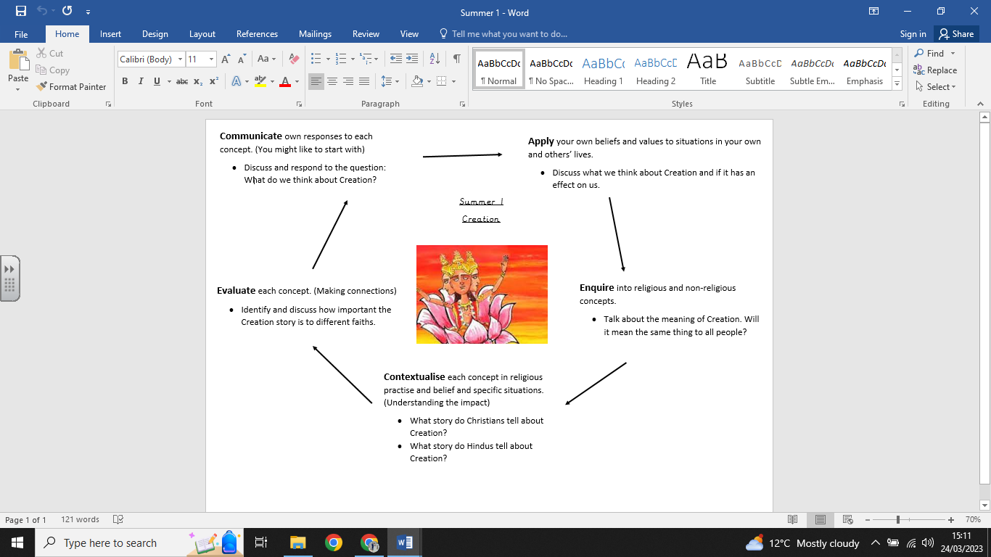

**What we already know:**

- Christians use water in a special ceremony called baptism, which welcomes people into the church.

- Babies or adults can be baptised. - Babies and adults often wear special clothing. - Christians tell the story of John of Baptist who baptised Jesus in the river Jordan.

- Hindu people see the River Ganges as precious.

- About the story of Shiva.

**What we are going to learn:**

* The concept of creation.
* Describe Christian and Hindu creation stories.
* Describe Hindus value these stories
* Give examples of how their responses to creation relates to their own and others’ lives

**What we are going to learn next time:**

* Express a personal response to the concept of protection.
* Describe how Hindus express protection in the festival of Raksha Bandhan.

**Key Vocabulary:**

* Heaven
* Cobra
* Lord Vishnu
* Peace
* Lotus flower
* Brahma
* Earth
* Lord Shiva

**Religious Education Knowledge Organiser: Year 1**

**Summer 1: Hindu Creation Stories**