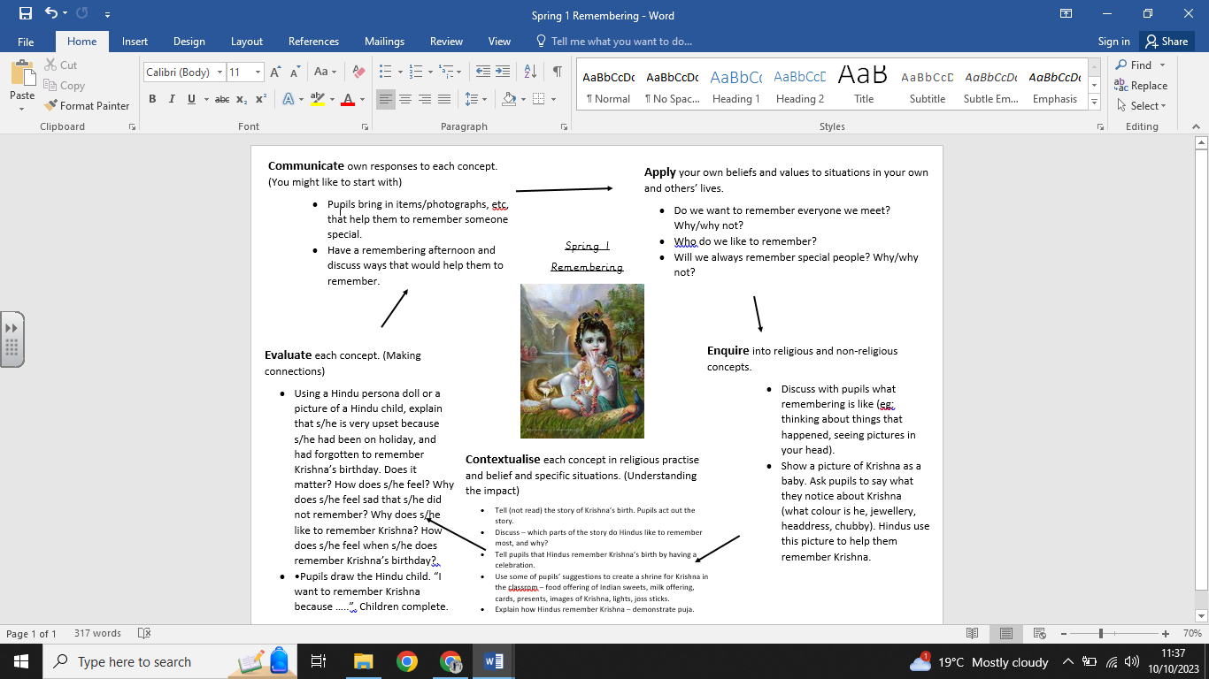

**What we are going to learn next time:**

-About the importance of candlelight.

-To respond to candlelight in different situations

-To describe how candlelight can be a symbol and what symbol means.

-How candles are used at Diwali as a symbol by describing its value to Hindu people.

**What we are going to learn:**

-What remembering means.

-That some Hindus remember Krishna by telling the story of his birth and by celebrating.

-About the importance of Hindus remembering Krishna’s birthday.

-About remembering someone special.

**Key Vocabulary:**

-Remembering

- Hindu faith

-Krishna

-Celebrate

**What we already know:**

No prior knowledge can be assumed

**Religious Education Knowledge Organiser: Year R**

**Spring 1: Remembering**