**Key Vocabulary:**

-Remembering

-Vishnu

- Holika and Prahad

-Holi

**What we already know:**

-About the importance of candlelight.

-To respond to candlelight in different situations

-To describe how candlelight can be a symbol and what symbol means.

-How candles are used at Diwali as a symbol by describing its value to Hindu people.

**Religious Education Knowledge Organiser: Year 2**

**Spring 1: Remembering Vishnu**

**What we are going to learn:**

- How Hindu people value the celebrations and devotions paid to Vishnu.

- Ways in which Hindu people remember events or people.

-To identify examples of situations when remembering is important to themselves or others.

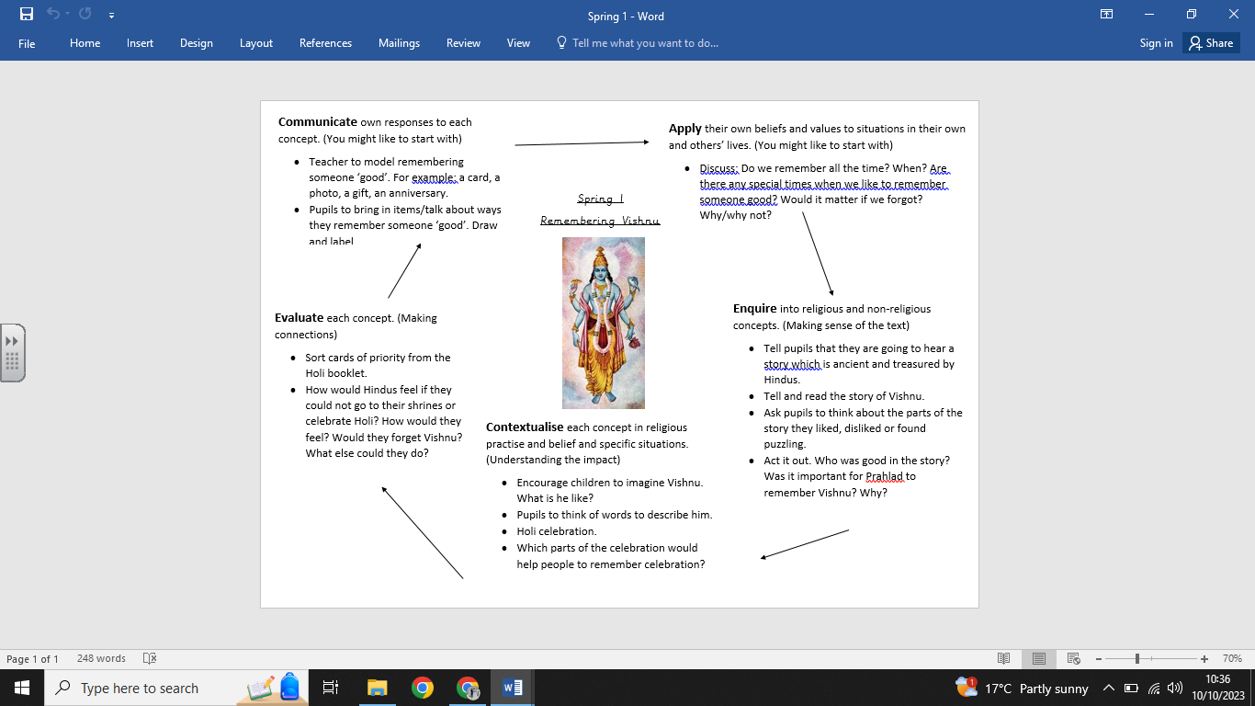

**What we are going to learn next time:**

People of God: Taking care of others.

(Year 3: Horndean Church of England Junior school)