Phonics, Reading and writing progression and expectations.

Little Wandle phonic progression for Reception.

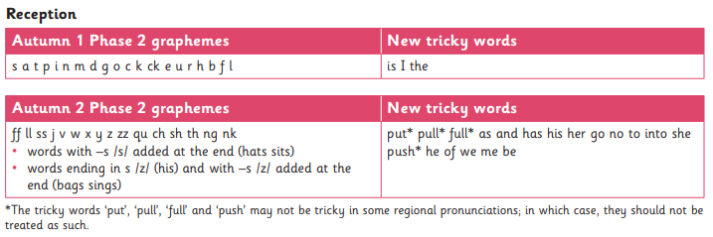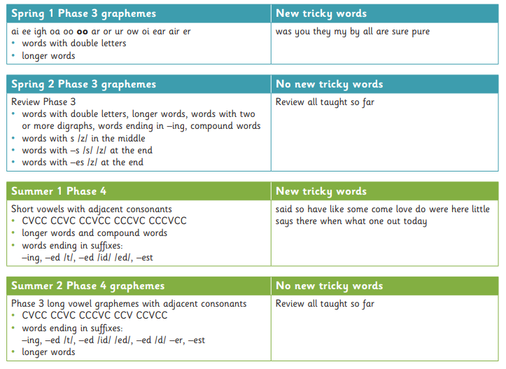

End of Reception expectations – Early Learning Goals

**Literacy Comprehension ELG**

Children at the expected level of development will:

• Demonstrate understanding of what has been read to them by retelling stories and narratives using their own words and recently introduced vocabulary;

• Anticipate – where appropriate – key events in stories;

• Use and understand recently introduced vocabulary during discussions about stories, non-fiction, rhymes and poems and during role-play.

**Word Reading ELG**

Children at the expected level of development will:

• Say a sound for each letter in the alphabet and at least 10 digraphs;

• Read words consistent with their phonic knowledge by sound-blending;

• Read aloud simple sentences and books that are consistent with their phonic knowledge, including some common exception words.

**Writing ELG**

Children at the expected level of development will:

• Write recognisable letters, most of which are correctly formed;

• Spell words by identifying sounds in them and representing the sounds with a letter or letters;

• Write simple phrases and sentences that can be ready by others.

Little Wandle phonic progression for Year 1

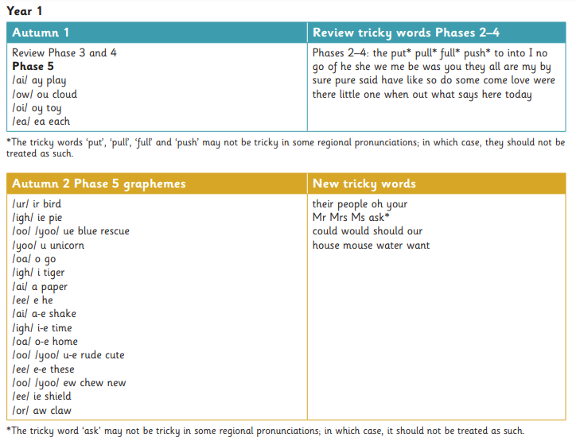

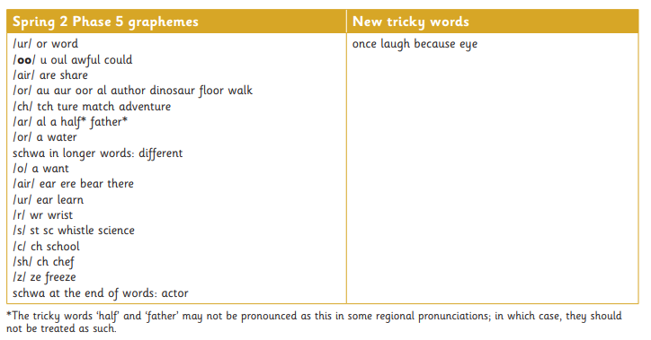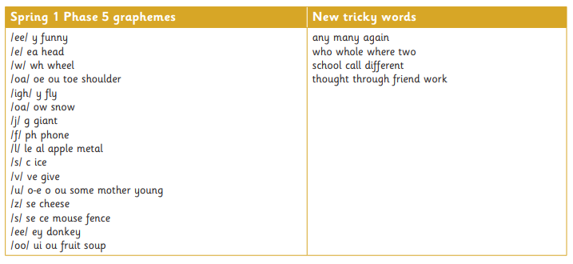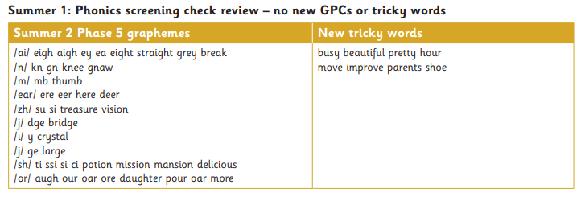

End of Year 1 expectations – National Curriculum

**Reading Comprehension**

Children at the expected level of development will:

* Say what they like or dislike  about a text
* Link what they read or hear to their own experiences
* Retell key stories orally using narrative language
* Understand and talk about the main characteristics within a known key story
* Learn some poems and rhymes by heart
* Use prior knowledge, context and vocabulary provided to understand texts
* Check that the text makes sense to them as they read and correct miscues
* Begin to draw inferences from the text and/or the illustrations
* Make predictions based on the events in the text
* Explain what they understand about a text

**Word Reading**

Children at the expected level of development will:

* Match all 40+ graphemes to their phonemes (Phase 3)
* Blend sounds in unfamiliar words
* Divide words into syllables, for example, pocket, rabbit, carrot, thunder, sunset
* Read compound words, for example, football, playground, farmyard, bedroom
* Read words with contractions, e.g. I’m, I’ll, we’ll, and understand that the apostrophe represents the omitted letter(s)
* Read phonically decodable texts with confidence
* Read words containing ‘s, es, ing, ed, er , est’ endings
* Read words which have the prefix –un added
* Add the endings –ing, –ed and –er to verbs where no change is needed to the root word
* Read words of more than one syllable that contain taught GPCs (grapheme, phoneme correspondence)

**Writing Transcription**

Children at the expected level of development will:

* Sit correctly at a table, holding a pencil comfortably and correctly
* Begin to form lower case letters in the correct direction, starting and finishing in the right place
* Form capital letters and the digits 0-9
* Understand which letters belong to which handwriting ‘families’ (i.e. letters that are formed in similar ways) and to practise these
* Identify known phonemes in unfamiliar words
* Use syllables to divide words when spelling
* Use knowledge of alternative phonemes to narrow down  possibilities for accurate spelling
* Use the spelling rule for adding s or es for verbs in 3rd person singular
* Name the letters of the alphabet in order
* Use letter names to show alternative spellings of the same phoneme

**Writing Composition**

Children at the expected level of development will:

* Compose a sentence orally before writing it
* Sequence sentences to form short narratives
* Sequence sentences in chronological order to recount an event or an experience
* Re-read what they have written to check that it makes sense
* Leave spaces between words
* Begin to punctuate sentences using a capital letter and a full stop, question mark or exclamation mark
* Use a capital letter for names of people, places, the days of the week, and the personal pronoun ‘I'
* Use ‘and’ to join sentences together
* Know how the prefix ‘un’ can be added to words to change meaning

**Year 2**

In Year 2, we initially continue to follow the Little Wandle Programme – reviewing and teaching any phonic gaps and developing word recognition, prosody and fluency, and comprehension. We then focus on spelling using the No Nonsense Spelling programme.

This helps children learn spelling patterns and rules, statutory words, common exceptions and personal spellings. No Nonsense Spelling teaches spelling in a 'Little-but-often' structure that allows children to revisit and review, learn new strategies and apply.

End of Year 2 expectations – National Curriculum

**Word Reading**

Children at the expected level of development will:

* Decode automatically and fluently
* Read accurately by blending the sounds in words that contain the graphemes taught
* Recognise and read alternative sounds for graphemes
* Read accurately words of two or more syllables that contain the same GPCs
* Read words containing common suffixes
* Read further common exception words
* Read and notice unusual correspondence between grapheme and phoneme
* Read most words quickly and accurately when they have been frequently encountered without overt sounding and blending
* Read aloud books closely matched to their improving phonic knowledge, sounding out unfamiliar words accurately, automatically and without undue hesitation
* Read books fluently and confidently

**Reading Comprehension**

Children at the expected level of development will:

* Talk about and give an opinion on a range of texts
* Discuss the sequence of events in books and how they are related to each other
* Use prior knowledge and context and vocabulary explored to understand texts
* Retell orally some stories, including fairy stories and traditional tales
* Read for meaning, checking that the text makes sense and correcting inaccurate reading
* Know and recognise simple recurring literary language in stories and poetry
* Talk about favourite words and phrases.
* Increase repertoire of poems learnt by heart, appreciating these and reciting some, with appropriate intonation to make the meaning clear
* Answer and ask appropriate questions and make predictions on the basis of what has been read so far
* Draw simple inferences from illustrations, events and characters’ actions and speech.

**Writing Transcription**

Children at the expected level of development will:

* Segment spoken words into phonemes and record these as graphemes
* Spell words with different alternative spellings, including a few common homophones
* Spell longer words using suffixes such as ment, ness, ful, less, ly
* Use knowledge of alternative phonemes to narrow down possibilities for accurate spelling
* Identify known phonemes in unfamiliar words and use syllables to divide words
* Form lower case letters of the correct size relative to one another
* Begin to use some of the diagonal and horizontal strokes needed to join letters
* Understand which letters, when adjacent to one another, are best left unjoined
* Write capital letters and digits of the correct size, with correct orientation and relationship to one another and to lower case letters
* Use spacing between words that reflects the size of the letters

**Writing Composition**

Children at the expected level of development will:

* Write narratives about personal experiences and those of others (real and fictional)
* Write for different purposes, including real events
* Plan and discuss the content of writing and write down ideas
* Orally rehearse structured sentences or sequences of sentences
* Evaluate writing independently, with peers and with teacher
* Proof-read to check for errors in spelling, grammar and punctuation
* Use full stops, capital letters , exclamation and question marks accurately to demarcate sentences and commas for lists
* Use a capital letter for names of people, places, the days of the week, and the personal pronoun ‘I’
* Use subordination (using when, if, that, or because) and co-ordination (using or, and, or but)
* Use present and past tenses correctly and consistently including the progressive form

**Book level expectation**

|  |  |  |  |  |
| --- | --- | --- | --- | --- |
|  |  | **End of year expectation** | | |
| **Phase /colour/band** | **On track expectation** | **Reception** | **Year 1** | **Year 2** |
| Foundation Level | Reception, Autumn 1 |  |  | Year 2 WBY (PK1) |
| Phase 2, set 1 | Reception, Autumn week 3/4 & Autumn 2 |  |  | Year 2 WBY (PK1) |
| Phase 2, set 2 | Reception, Autumn 2 |  |  | Year 2 WBY (PK1) |
| Phase 2, set 3 | Reception, Autumn 2 |  |  | Year 2 WBY (PK2) |
| Phase 2, set 4 | Reception, Spring 1 |  |  | Year 2 WBY (PK2) |
| Phase 2, set 5 | Reception, Spring 1 |  |  | Year 2 WBY (PK3) |
| Phase 3, set 1 | Reception, Spring 2 | **REC ELG** |  | Year 2 WBY (PK3) |
| Phase 3, set 2 | Reception, Summer 1 |  | Year 1 BLW | Year 2 WBY (PK3) |
| Phase 4, set 1 | Reception, Summer 2 |  | Year 1 BLW | Year 2 BLW (PK4) |
| Phase 4, set 2 | Year 1, Autumn 1 |  | Year 1 WTS | Year 2 BLW (PK4) |
| Phase 5, set 1 | Year 1, Autumn 2 |  | Year 1 WTS | Year 2 BLW (PK4) |
| Phase 5, set 2 | Year 1, Spring 1 |  | Year 1 WTS | Year 2 BLW (PK4) |
| Phase 5, set 3 | Year 1, Spring 2 |  | Year 1 WTS | Year 2 BLW (PK4) |
| Phase 5, set 4 | Year 1, summer 1 & 2 |  | **Year 1 ARE** | Year 2 WTS |
| Phase 5, set 5 | Year 2, Autumn 1 |  | Year 1 ARE+ | Year 2 WTS |
| Turquoise | Year 2, Autumn 2 |  | Year 1 ARE+/GDS | Year 2 WTS |
| Purple | Year 2, Spring 1 |  |  | Year 2 WTS |
| Gold | Year 2, Spring 2 |  |  | **Year 2 ARE** |
| White | Year 2, Summer |  |  | **Year 2 ARE** |
| Lime |  |  |  | Year 2 ARE+/GDS |
| Lime + |  |  |  | Year 2 GDS |