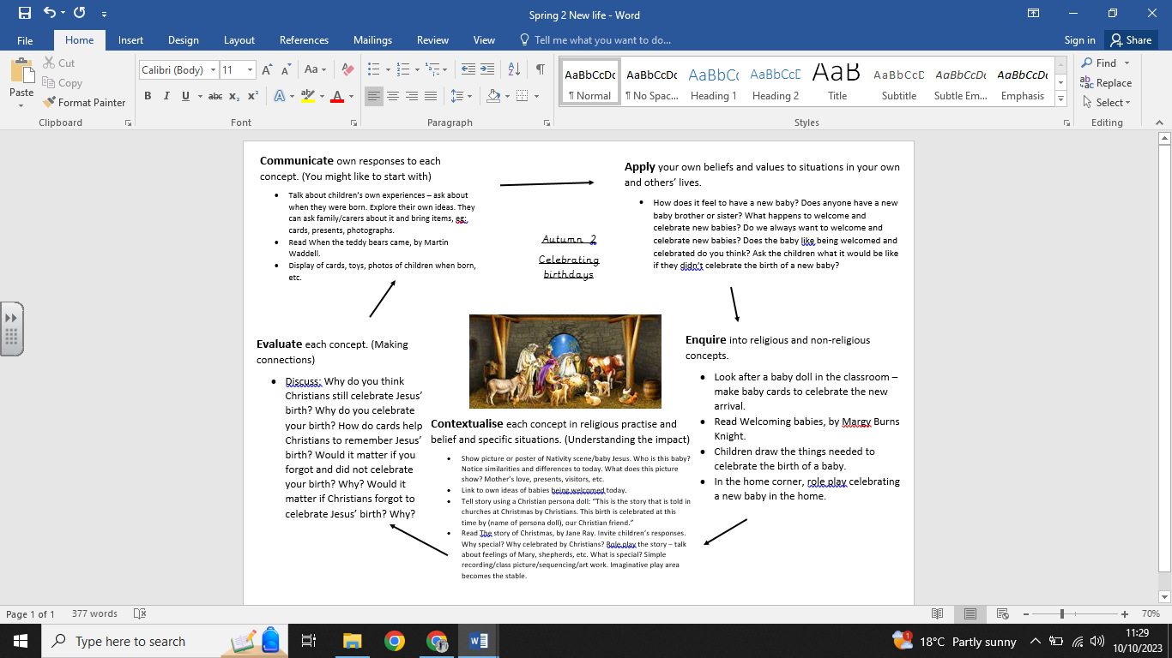

**What we are going to learn:**

* That Christians believe that Jesus was born at Christmas.
* How Christians celebrate Jesus’ birth.
* The Christmas story from the Bible.

**What we are going to learn next time:**

* An account of the story of Jesus’ birth and why Jesus is important for Christians.
* To recognise that stories of Jesus’ life come from the Gospels.
* Ways in which Christians use the story of the nativity to guide their beliefs and actions at Christmas.
* How to be thankful at Christmas time.

**Key Vocabulary:**

* Christmas -Shepherds
* Jesus
* Nativity
* Birth
* Mary
* Joseph

**What we already know:**

No prior knowledge can be assumed

**Religious Education Knowledge Organiser: Year R**

**Autumn 2 – Celebrating birthdays**