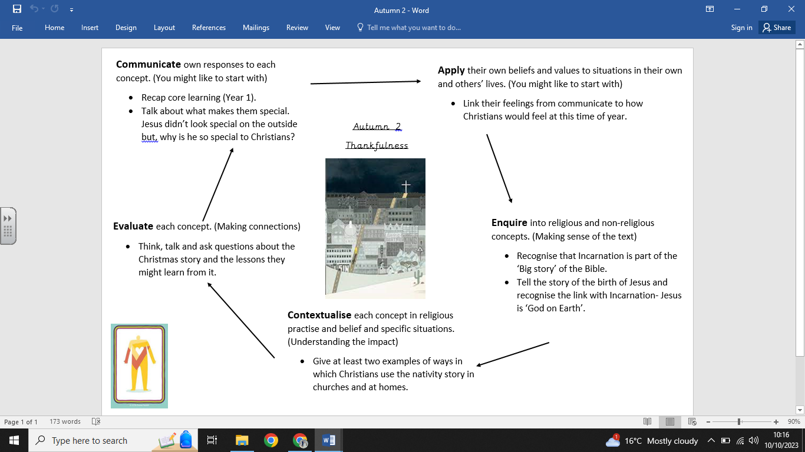

**What we are going to learn next time:**

Special clothing – Sikhism: Appreciatingdifferences.

Year 3: Horndean Junior School

**What we are going to learn:**

- That Incarnation is part of the ‘Big Story’ of the Bible.

- The story of the birth of Jesus and recognise the link with Incarnation — Jesus is ‘God on Earth’.

-Examples of ways in which Christians use the nativity story in churches and at home.

-To ask questions about the Christmas story and the lessons they might learn from it.

**Key Vocabulary:**

* Christmas -Shepherds -Angel
* Jesus - Preparations -Giving
* Nativity - Gospel
* Birth - Advent
* Mary -King
* Joseph -Wise men

**What we already know:**

-An account of the story of Jesus’ birth and why Jesus is important for Christians.

-To recognise that stories of Jesus’ life come from the Gospels.

-Ways in which Christians use the story of the nativity to guide their beliefs and actions at Christmas.

-How to be thankful at Christmas time.

**Religious Education Knowledge Organiser: Year 1**

**Autumn 2 – Preparations**