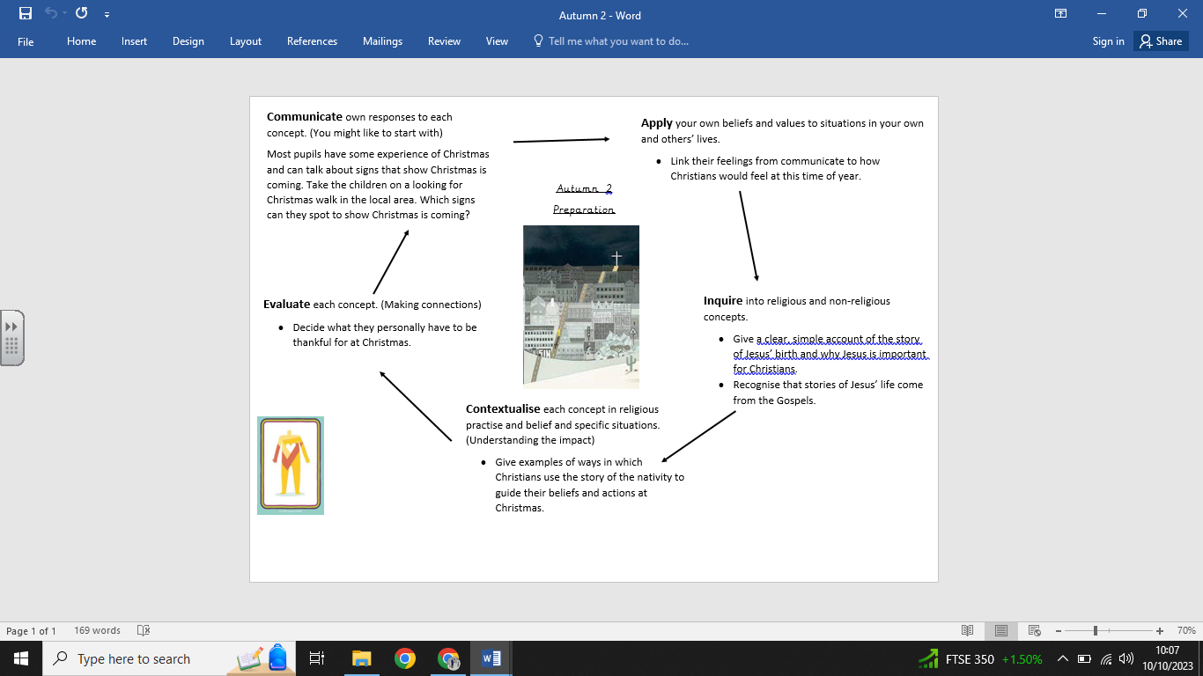

**What we are going to learn next time:**

- That Incarnation is part of the ‘Big Story’ of the Bible.

- The story of the birth of Jesus and recognise the link with Incarnation — Jesus is ‘God on Earth’.

-Examples of ways in which Christians use the nativity story in churches and at home.

-To ask questions about the Christmas story and the lessons they might learn from it.

**What we are going to learn:**

-An account of the story of Jesus’ birth and why Jesus is important for Christians.

-To recognise that stories of Jesus’ life come from the Gospels.

-Ways in which Christians use the story of the nativity to guide their beliefs and actions at Christmas.

-How to be thankful at Christmas time.

**Key Vocabulary:**

* Christmas -Shepherds
* Jesus - Preparations
* Nativity - Gospel
* Birth - Advent
* Mary -
* Joseph

**What we already know:**

- That Christians believe that Jesus was born at Christmas.

- How Christians celebrate Jesus’ birth.

- The Christmas story from the Bible.

**Religious Education Knowledge Organiser: Year 1**

**Autumn 2 – Preparations**