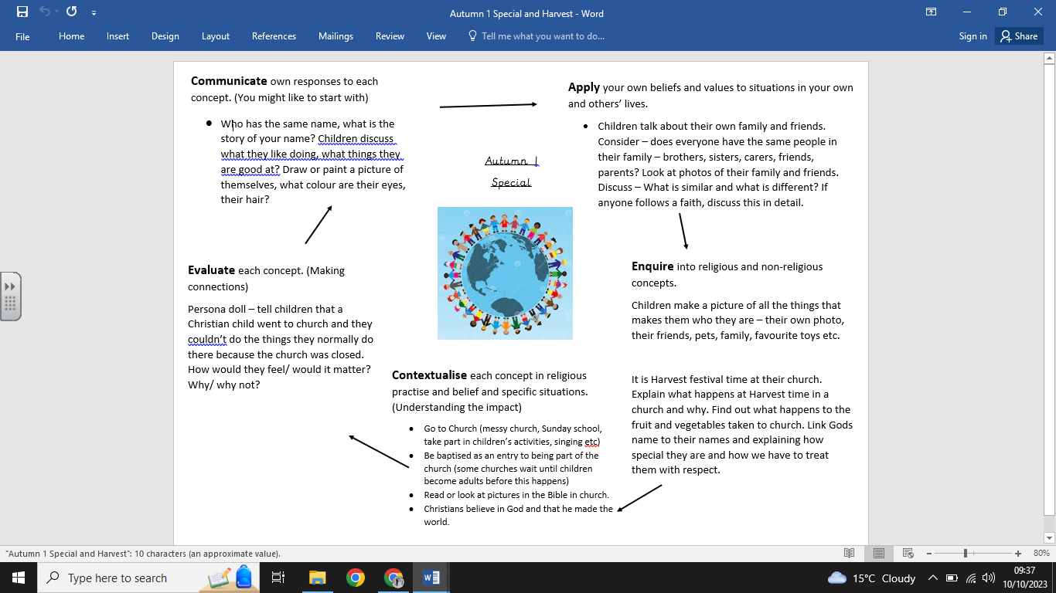

**What we are going to learn:**

* What makes us special.
* What makes someone Christian.
* That God is important to Christians.
* What happens at a Harvest festival.

**What we are going to learn next time:**

* Christians believe God made the world.
* The story of creation from Genesis 1:1–2.3.
* That the story tells Christians about God, Creation and the world.
* What Christians do to say thank you to God for the Creation.
* To ask questions about living in an amazing world.

**Key Vocabulary:**

* Harvest
* God
* Christian
* Church
* Bible

**What we already know:**

No prior knowledge can be assumed

**Religious Education Knowledge Organiser: Year R**

**Autumn 1 - Special**