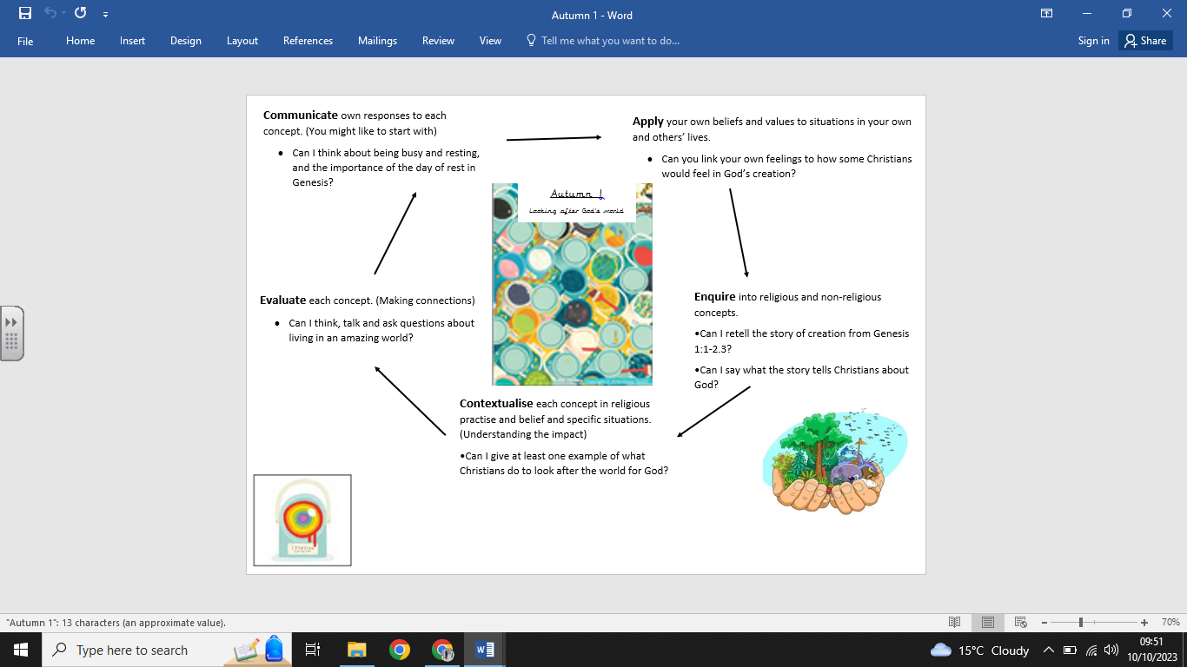

**Key Vocabulary:**

* God -Creator
* Christian -Rest
* Church
* Bible
* Creation
* Genesis
* Thankful

**What we already know:**

-- Christians believe God made the world.

- The story of creation from Genesis 1:1–2.3.

- That the story tells Christians about God, Creation and the world.

- What Christians do to say thank you to God for the Creation.

**What we are going to learn:**

- About and understand why God gave us a day of rest.

- How Christians should spend their day of rest if they are living their life like Jesus did.

- Examples of how Christians look after the world for God.

**What we are going to learn next time:**

Creation and the Fall: Our responsibility to look after God’s creation.

(Year 3 Horndean Junior School)

**Religious Education Knowledge Organiser: Year 2**

**Autumn 1 – Looking after Gods world.**