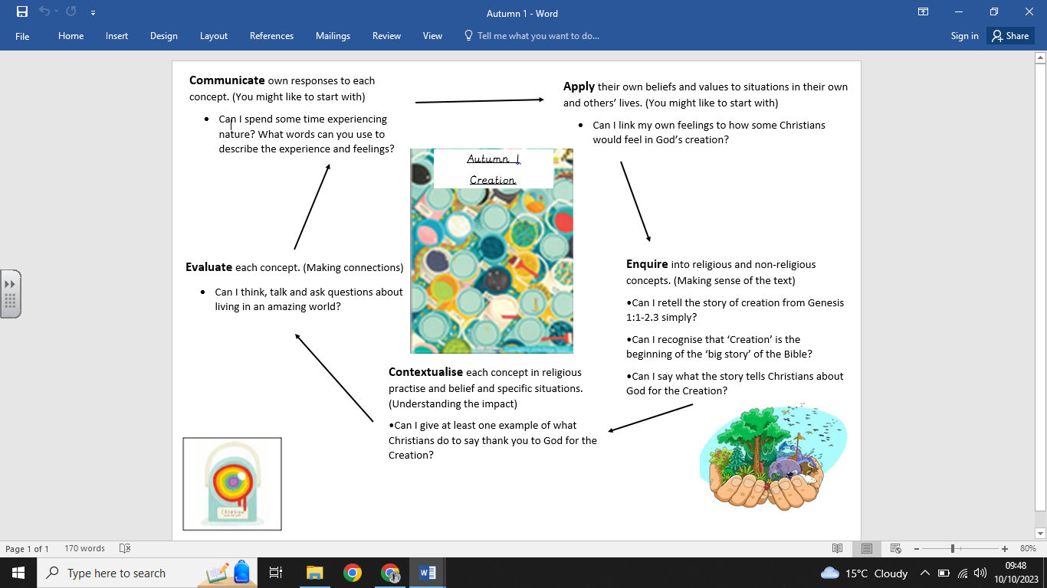

**Key Vocabulary:**

* God
* Christian
* Church
* Bible
* Creation
* Genesis
* Thankful

**What we already know:**

- What makes us special.

- What makes someone Christian.

- That God is important to Christians.

- What happens at a Harvest festival.

**What we are going to learn:**

- Christians believe God made the world.

- The story of creation from Genesis 1:1–2.3.

- That the story tells Christians about God, Creation and the world.

- What Christians do to say thank you to God for the Creation.

- To ask questions about living in an amazing world.

**What we are going to learn next time:**

- About and understand why God gave us a day of rest.

- How Christians should spend their day of rest if they are living their life like Jesus did.

- Examples of how Christians look after the world for God.

**Religious Education Knowledge Organiser: Year 1**

**Autumn 1 - Special**